1 Based on what you have learnt in the class, do the following steps:
- Create a new folder
- b. Put the following files in the folder
Code.txt
Log.txt
Output.txt
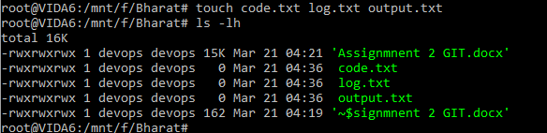
- Stage the Code.txt and Output.txt files
For staging we need to use git add command, using this command in git we can move form working area to staging area. As shown in below command:
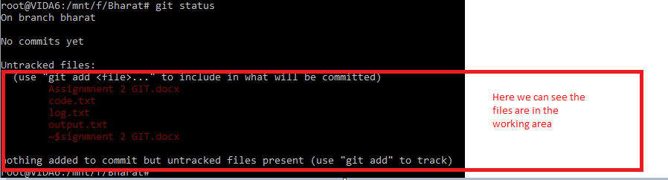
After then using git add code.txt and output.txt
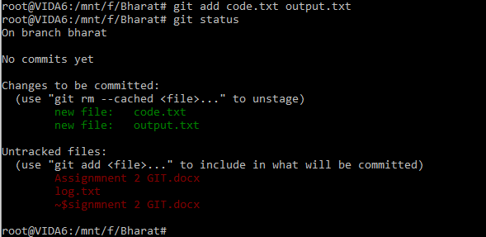

- Commit them
Command used for commit : git commit -m “commit name”
We can also call commit at version or check point.
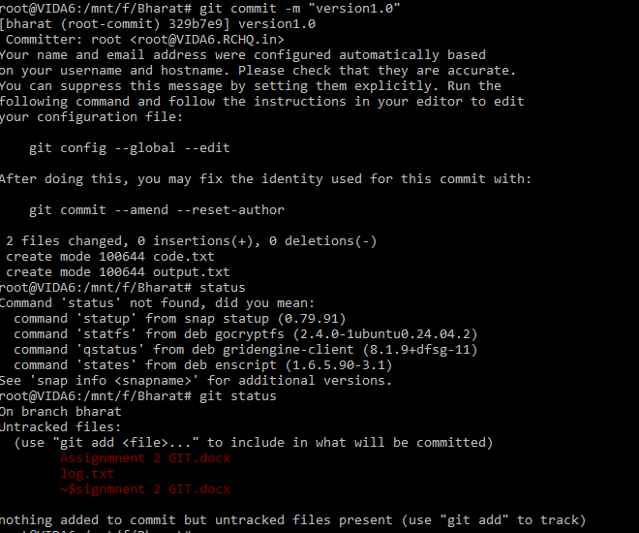

From git log we can check the commit details
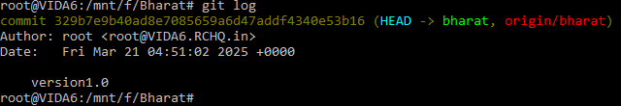

E: And finally push them to GitHub
For push any data to git hub repository git push -u origin brnachname